NJ Earned Sick Leave for Parents & Guardians
Media Kit for School Communities

NJ Department of Labor Earned Sick Leave Landing Page: mysickdays.nj.gov

Facebook & Twitter posts:

#1
NJ working parents & guardians – you can use your earned sick leave to attend parent-teacher conferences, and other school meetings and events. It’s the law! Learn more at mysickdays.nj.gov. @NJLaborDept #EarnedSickLeave #KnowYourRights

#2
NJ working parents & guardians – you can use your earned sick leave to attend IEP meetings, and other appointments for your child’s disability or health. It’s the law! Learn more at mysickdays.nj.gov. @NJLaborDept #EarnedSickLeave #KnowYourRights

Facebook-optimized graphic:

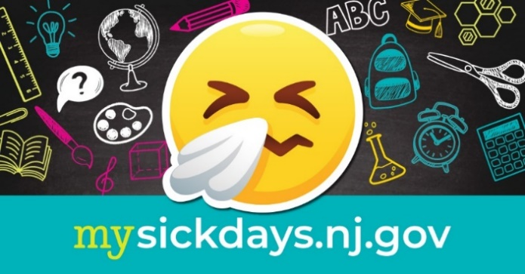

Twitter-optimized graphic:

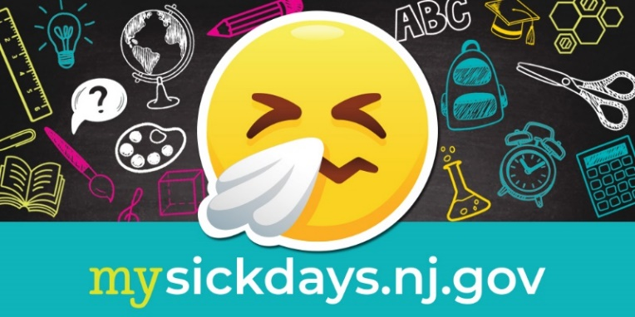

Other Media:
Copy and paste this image of the Earned Sick Leave handout for parents and guardians into your school or district newsletter, e-newsletter, or email blast. Please be sure it’s large enough to be easily read. For PDF versions, see mysickdays.nj.gov.
